

BAPTIST CHURCH

November

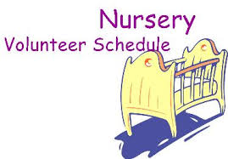
Nov 6……….……Judy Broussard, Otisann McManus
Nov 13……….………….….….Jana Moore, Teresa Schane
Nov 20………...……………Angie Fisher, Rachel Merrell
Nov 27…………………….Leigh Veilleux, Terri Edwards

Weekly Service & Activity Schedule:

SUNDAY
Sunday School 9:45 a.m.
Morning Worship Services 11:00 a.m.
Evening Worship Services 6:00 p.m.

WEDNESDAY
Meal/Wednesday Bible Study. 6:30 p.m.

1662 CR 305

McDade, TX 78650

Phone: (512) 273-2743

Email: KnobbsSpringsBaptist@gmail.com



KnobbsSpringsBC.com

David Atwood – Pastor
(512) 470-5098

Patti Radford - Office Manager

KnobbsSpringsBaptist@gmail.com
512-273-2743

November Ushers
Kenny Merrell, Wesley McManus,
Tom Veilleux, Mickey Stanford

November Hostesses

Jean Griffith, Shirley Marecle.

Sheri Beauchamp, Jane Tooley
WHAT’S GOING ON?

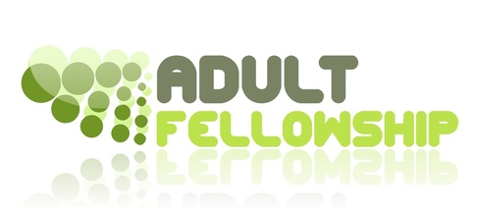
2nd & 4th Thursday of every month

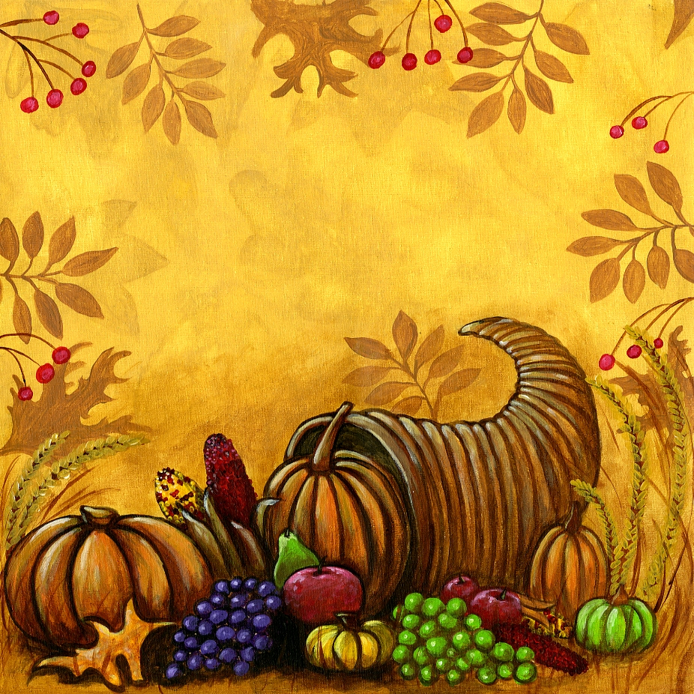
Join us Saturday, Nov. 12 for KSBC’s Annual Harvest Stew! Great food, games for the kids, gospel music, 42 tournament, wonderful fellowship. Festivities begin about 4:00 pm.


New Commandment Kids
Ages Kinder-12th grade are welcome! Hands on mission work thru puppet ministry and crafts to share with nursing homes, shut-ins, etc. Meeting every 1st and 2nd Sunday of each month @9:30 am

November
6 & 13….………New Commandment Kids
6…………………..Turn Your Clocks Back
10 …………………..……Adult Fellowship
12………….…………………Harvest Stew
13-15..…Texas Baptist Annual Mtg/Waco
13………………………..Business Meeting
14-18………...…Collection Week for OCC
24………………………….…Thanksgiving
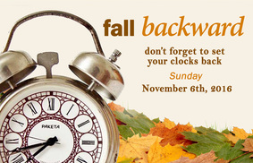

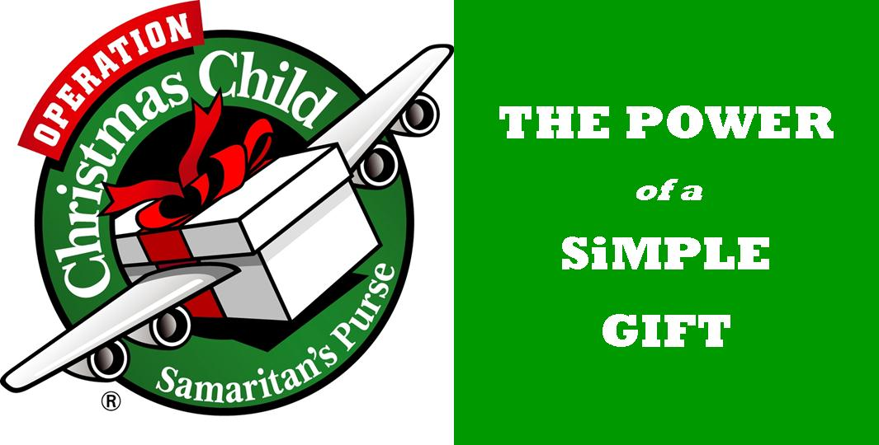
Shoebox packing was a huge success!! We packed 262 boxes!! Most going to Operation Christmas Child to be distributed worldwide and some going to Sam Craig Ministries to be distributed in the U.S. Paula Knobloch will be taking the boxes to the distribution center the week of Nov 14. Please pray these boxes get to the children God intended.



When we think Of November, we think of Thanksgiving, the time we traditionally give thanks for the harvests of the year. Its history in North America is rooted in English tradition dating from the Protestant Reformation. Most people recognize the first Thanksgiving celebration as having taken place in Plymouth, Massachusetts in 1621.
As Christians, we should ALWAYS be thankful for the blessings that God has poured out on us, not just at one time of the year.
In the Gospels, Jesus made mention of the “harvest that is plentiful, but the workers are few”, referring to the lost souls of this earth who need to hear the gospel of our Lord Jesus. I pray all of us would be diligent in sowing the seeds of righteousness through our lives, so those lost souls may see and know the love of Jesus.
We, as workers for Jesus, need to be busy; we are all busy, but we need to be busy doing HIS work. The Bible says, “Faith without works is dead.” I pray that in this season of Thanksgiving, we will remember all of those who do not have the hope that we do, and will be HIS hands and feet to bring the gospel to them.
The church calendar is filled with activities this month; Harvest Stew, the Annual Baptist Convention, as well as other monthly activities. I hope you will make a concerted effort to be a part of all of our activities that promote fellowship and Christian growth.
Remember to vote your Christian convictions in the upcoming presidential election.
For those of you who took the “Killing Christians” books, make sure when you finish reading it, please return it to the church foyer so others can read this book. How many of you are part of the “8 Thirty 8” prayer movement that I mentioned in my sermon several weeks ago? If you’re not, and you don’t know what I’m talking about, ask me!

God bless you all,
David L. Atwood
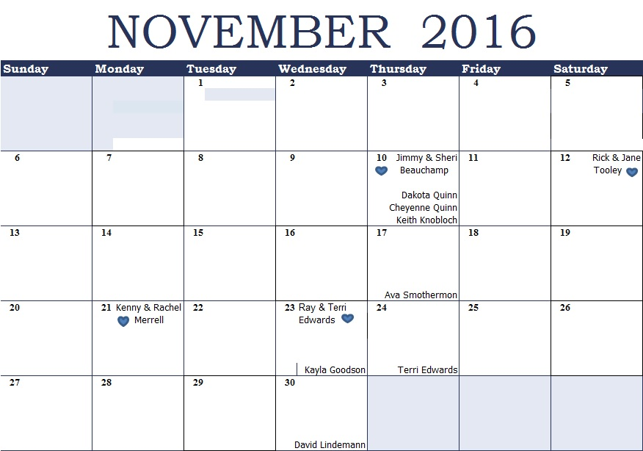
K s b c
Keeping His Word through Sunday School, Bible Study and Church Attendance/Worship
Sunday School Bible Studies for November:
Nov 6th Unstoppable Opportunities Acts 3:1-10 Nov 13th Unstoppable Courage Acts 4:1-3,8-12,19-20 Nov 20th Unstoppable Impact Acts 17:16-18,22-23,30-31 Nov 27th Give Thanks---Anyway! 2 Chronicles 20:10-12,14-17,20-22,29-30

9:45 a.m. each Sunday – A place for everyone
WE’D LOVE FOR YOU TO JOIN US!

